A PRELIMINARY REPORT ON

“PLACEMENT MANAGEMENT SYSEM”

SUBMITTED TO THE EDUBRIDGE INDIA PRIVATE LIMITED

SUBMITTED BY

Miss. Wale Dipali Sampat Batch No: EON-5736

Under The Guidance of
Amruta Deore



DEPARTMENT OF SPRAYAS CERTIFIED JAVA FULL STACK DEVELOPER 02

THANE EDUBRIDGE INDIA PRIVATE LIMITED 2021-2022.

ACKNOWLEDGEMENT

I take this opportunity to express my gratitude and respect to all those who have helped me throughout my training period on the project. This project would not have been possible without the valuable guidance of my Course Instructor “Mss.AmrutaDeore” (EDUBRIDGE INDIA PRIVATE LIMITED) who taught me the basic concepts of Core Java and Database handling(SQL) and whose guidance throughout the entire work enabled me to complete this project successfully.
I owe my regards to the entire faculty of the department of Computer Science at EDUBRIDGE INDIA PRIVATE LIMITED from where I have learnt the java and I express my sincere thanks to all my fellow course mates who supported me in my project through various informal discussions which were very valuable to the successful completion of my project.

Miss. Wale Dipali Sampat

ABSTRACT

From a student’s perspective, placements can bring a wide range of benefits and opportunities. Training and management of placement is a crucial part of an educational institution in which most of the work is done manually. Manual system in the colleges requires a lot of manpower and time. With this project we aim to develop a web portal to solve this issue. The project is aimed at developing an application for the placement department of the college. The system is an application which will be accessed and effectively used throughout the organization with proper login enabled. It can also be used as an application for the Placement Officers in the college to manage the student information about placement thus reducing the manual work and consumes less paperwork. The system also provides the facility of viewing the personal and academic information of the student. The system gets the requested list of candidates for the companies who would like to recruit the people according to their eligibility criteria. Hibernate framework is used to facilitate the process of making the program.

CONTENTS

List of Topics: Page No

- Summary of Project…………………………………………………….….. 5
- Objectives…. …………………………………...........……………………...6
- System Specification …………………………...........……………………...7
- Introduction …………………………………...........………………….…...8
- Purpose…… …………………………………...........………………….…...9
- Scope…………………………………………...........……………….……...10
- Project…….. ………………………..............................................................11
- Snap shots of the tables………….……………………………..…….……..12
- Snap shots of the module.………….……………………………..…….…..13
- ER Diagram……………..………….……………………………..…….…...15
- Future Scope of project.………………………………………………..........16
- Conclusions……………………………………………………………..........17
- References…………………………………………………………................18
- Github Link..…………………………………………………………............19

SUMMARY OF THE PROJECT

The project named “Placement Mgmt. System”, a student/company information system is a window based application created in Core Java. The project has been developed on the basis of “Placement Cell” being presently used in the University for storing and retrieving the information of students and companies who are registered in placement cell. The Placement Cell maintains a large database of students wherein all the information of student including the personal records and the academic performance in terms of the marks and grades is stored and company information including resume of company and facilities it provide. The software retrieves this data and displays as per the user requirement.

OBJECTIVE:

The Placement Management System was developed as an attempt to take a record of company and students by restricting such a large database to that of a particular class of students or company.. The System provides the facility of viewing both the personal and academic information of the student and company it can also search for eligible students and company and also insertion and deletion of records by the administrator. The GUI used for the project provide instruction and the various actions performed on button clicks or on selection of items, guide the user through a series of pages as in the Project.

System Specification
- Operating System - Windows 10.
- Platform – Eclipse.
- JDK-1.8,1.16.
- Server-Tomcat 8.5,10.
- Language – HTML,CSS, Hibernate, Java, MYSQL,SQLYUG

INTRODUCTION

Manual Training and Placement which is done at various colleges is by human intervention due to which there is a maximum chance of errors. The major problem is searching and updating of the student data. Placement officers have to manage the student’s profile and their documents. Placement Officer has to collect the information of various companies who comes for recruitment. They have to arrange profiles of students according to various streams and notify them each time according to company requirements. Placement officers submit the information of students and if any changes or updates are required in the profile of any student, it hasto be done manually. This process is so difficult and tedious when the number of users increases. This is tedious and time-consuming. Chances of missing data are also possible. It is also difficult for collecting, managing, and updating student data as the number of students.’ Placement Management System’ like many other placement management web sites, provides information on placement providers and the placements and also keeps up to date information of all students. It is a platform where students can view and assess their opportunities.. A profile for each student is created with the necessary credentials for the portal. The system uses MySQL for database management and will sort the data of the student based on eligibility criteria.

PURPOSE
Placement Management System manages student information in the college with regard to placement. It improves existing system .It has the facility of maintaining the details of the student, thereby reducing the manual work. It will save time and energy which are spending in making reports and collecting data. Placement Management System can be accessed throughout the college with proper login provided

SCOPE
The project has a wide scope. Our project mainly helps in improving productivity and makes use of utilization of resources. There is no duplication of work as this was not the case when done manually. Thus it reduces labor and increases morale. The system intends user friendly operations which may resolve ambiguity. The project is a total management and informative system, which provides the up- to-date information of all the students in the college. Our system also help the college to overcome the difficulty in keeping records of hundreds of students and searching for a student eligible for recruitment criteria from the whole thing. It helps in effective and timely utilization of resources. The project facilitates user friendly, reliable and fast management system. The placement officer itself can carry out operations in a smooth and effective manner. They need not concentrate on record keeping. The college can maintain computerized records thus reducing paper work, time and money.

PROJECT

- Objective of the Project
- Description of the Project
- Snap shots of the tables
- Snap shots of the module
- ER diagrams
- Future Scope of the project
- Conclusion

PROJECT
The main objective of Placement Management System is to develop a student and company information system. Although such a project has a very wide scope, this project contains the most important part i.e. displaying the personal and academic information of a student and company. The students and companies are also provided with the facility of editing some fields like username and password. The project also allows a Data Base Administrator to enter the information of a student and company which is then stored in the corresponding tables in the main database .He can also delete the student and company information after placement is over from the main database.

Objective of the Project

- The main objective of Placement Management System is to develop a student and company information system.

- Easy to find out the list of eligible students attending the drive

- It manages the details of student records, placement training, different placements happening in and out of the college.

- Saves the time of placement officer and faculties.

- Reduces the manual works.

- This system makes student information more secure

- Snap shots of the tables

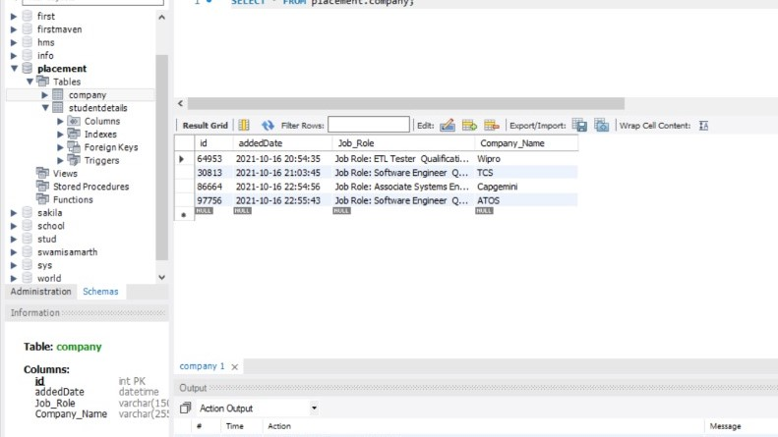

- Snap shots of the tables

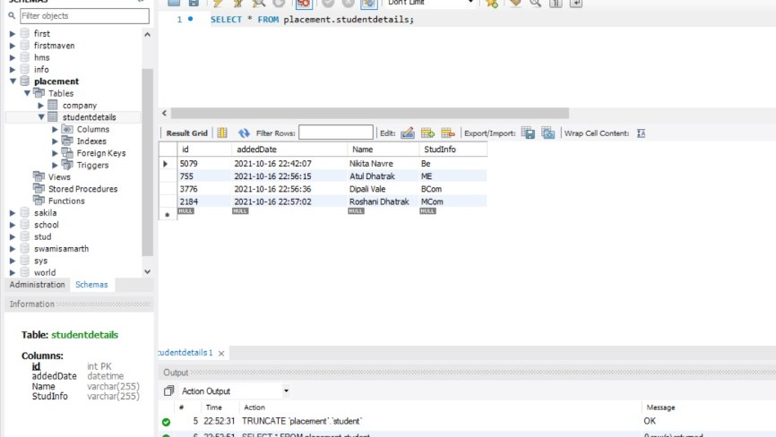

- Snap shots of the modules

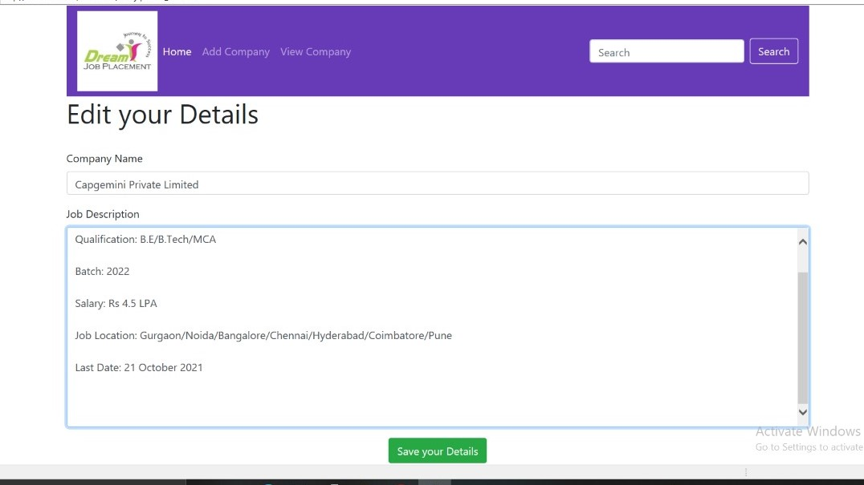

Snap shots of the modules

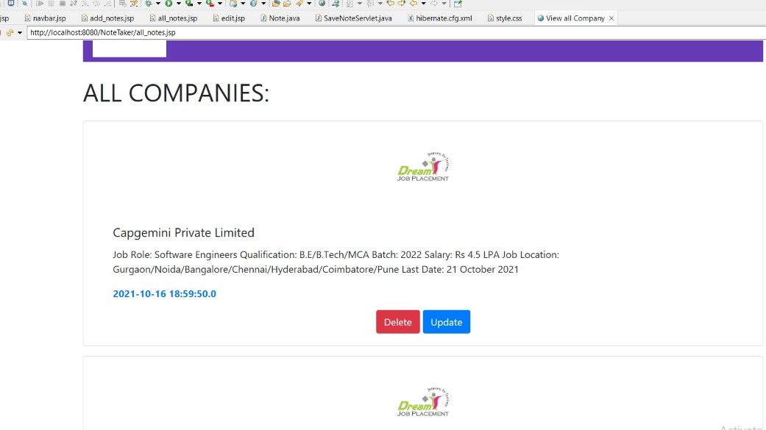

- Snap shots of the modules

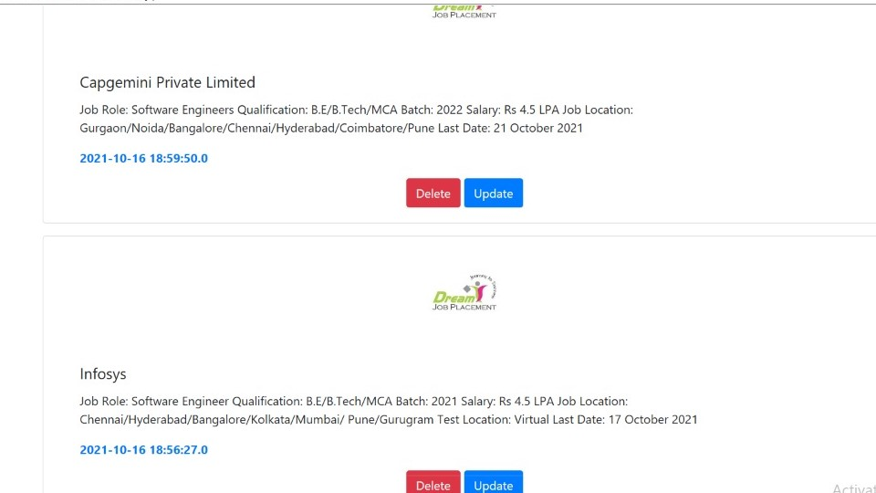

- Snap shots of the modules

- Snap shots of the modules

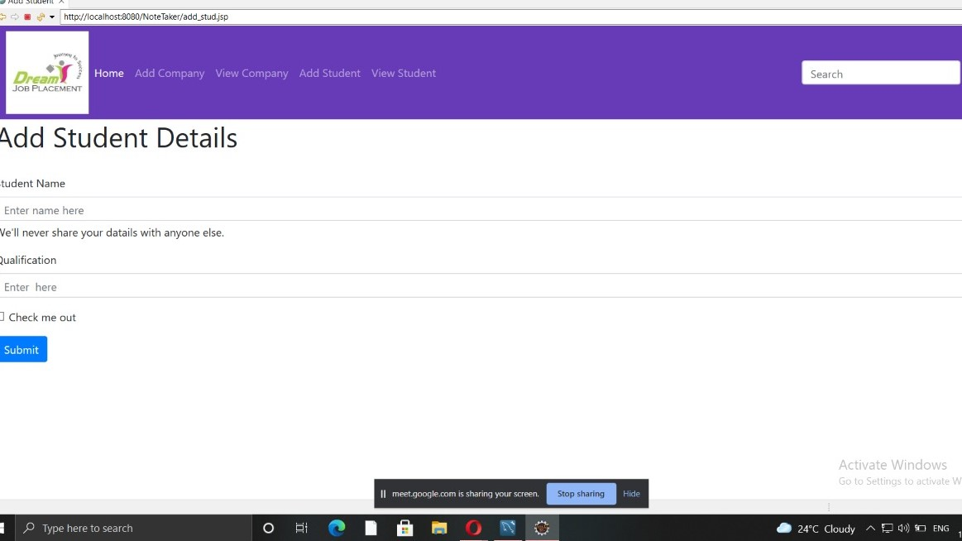

- Snap shots of the modules

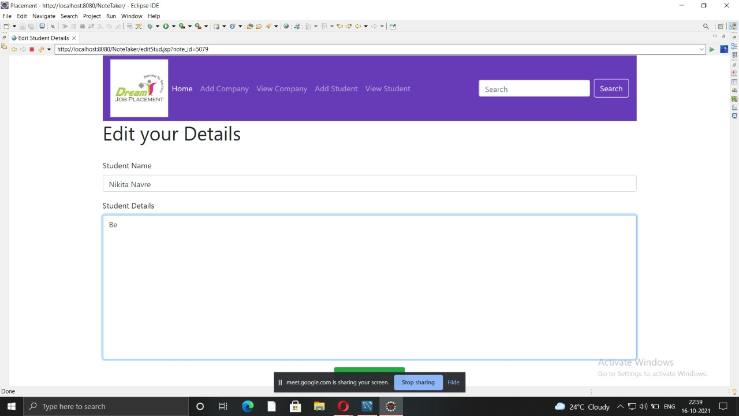

- Snap shots of the modules

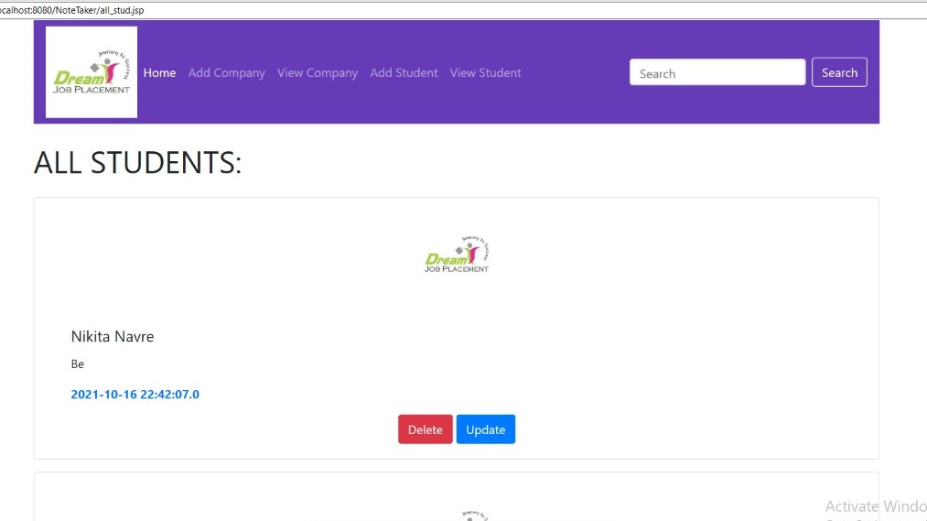

- ER diagrams

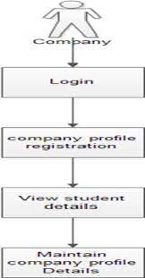

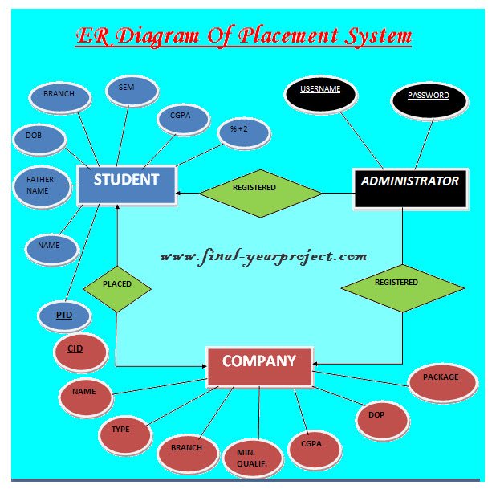

- Future Scope of the project

- The project is easily extensible and can be improved by further incremental releases of the same.
- We can extend this project by sending emails to companies and students information regarding placement dates, other eligibility criteria also.
- New modules can be easily added as it requires only an addition of a new package on button click.

- Conclusion

- It has the facility of maintaining the details of the student, there by reducing the manual work.
- It will save time and energy which are spending in making reports and collecting data.
- This project has been completed successfully to college Web based placement management system by maintaining the student details related to placement in an efficient manner.

REFERENCES
- www.edubirdgeindia .com
- www.google.com
- www.javatpoint.com
- www.w3 school.com

GitHub Link

https://github.com/dipawale6/proj.git

